A000-Am,C-Taino-Pendant-Fish Cemi-Bohique Cemi-Manatee Rib-1000 CE

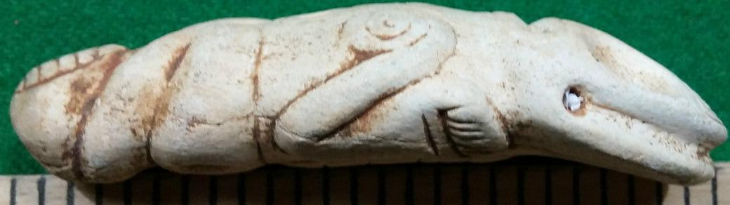

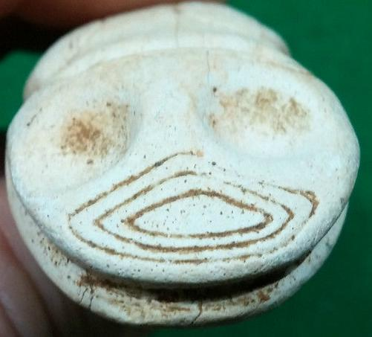

Figs. 1-2. Am,C-Taino-Pendant-Fish Cemi-Bohique Cemi-Manatee Rib-1000 CE

**Case No.: 18**

**Accession No.** Am,C-Taino-Pendant-Fish Cemi-Bohique Cemi-Manatee Rib-1000 CE

**Display Description:**

This pendant can be identified as a human cemi because of his navel which is an outlined circle in Fig. 1. This pendant shows the transformation of the individual into a swimming being, which is a common feeling of being in a hallucinogenic state. The concentric circles are Sun symbols of YaYa and indicate that this individual is unselfishly devoted to her works on earth. **Therefore, we may propose that this is a Bohique or shaman transforming into a fish spirit or cemi.** According to Pané there were twelve orders of spiritual entities that exemplified energies of a Supreme Being. These energies were encompassed in *cemís* which were intermediaries, much like Judaeo-Christian angels or Roman Catholic Saints. Since the repertoire of stone artifacts has now been relatively exposed to scientific scrutiny, each of the cemís spirits can be paired with its wood, stone, shell or textile material representation (Arrom 1975). The Taino also had a tripartite cosmos recorded by Pané which encompassed the sky, the earth and a lower world. These layered divisions are indicated on their most prominent artifact, the Three-pointed Sculpture.

**LC Classification: F1909**

**Date or Time Horizon: 1000 CE**

**Geographical Area: E Hispaniola, i.e., Dominican Republic**

**Map:**

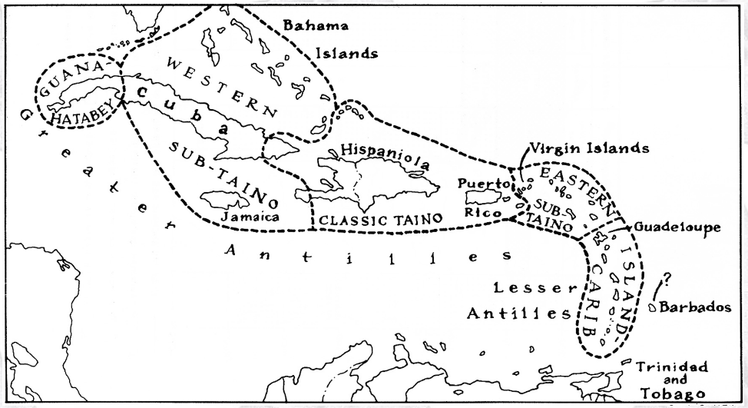

Caribbean c 1500 after http://www.latinamericanstudies.org/maps/Ciboney-Taino-Carib-

GPS coordinates:

**Cultural Affiliation:** Taino

**Medium:** conch shell

**Dimensions:**

**Weight:**

**Condition: original**

**Provenance:** from theDominican Republic

**Discussion:**

Pané was a Catalan a Hieronymite monk of the Order of St. Jerome. These hermit monks lived according to the Rule of Saint Augustine, which stresses chastity, poverty, obedience, worldly detachment, physical labor, fraternal charity, common prayer, fasting and abstinence. Saint Jerome, a fifth-century hermit and biblical scholar, formulated the rules of the order. In the eyes of the Spanish church hierarchy, Pané was a poor Hieronymite hermit, a Catalan peasant not of Castilian origins and was dismissed probably for these social reasons by the Spanish Dominican Bartolomé de Las Casas (ca. 1484– 18 July 1566) as a “simple man” with “limited faculties” (Pané p. 57), whose efforts, “amounted to nothing more than to say the Ave María and Pater Noster to the Indians, and some words about there being a God in heaven who was the creator of things, according to what he was able to teach them with abundant flaws and in a muddled way” (Pané p. 57). However derogatory Las Casas’ criticisms of Pané are, Pané’s *Account* is still the best source of information on the Taíno.

**References:**

Alexander, Hartley Burr. "Latin-American." The Mythology of All Races. Vol. XI. New York: Cooper Square Publishers, 1964.  
Arrom, José Juan. Mitolog’a y Artes Prehispánicas de las Antillas. México: Siglo XXI Editores, 1989.  
Bartlett, John. Familiar Quotations. Boston: Little, Brown & Co., 1980.  
Benzoni, M. Girolamo. La Historia del Mundo Nuevo. Trans. Marisa Vannini de Gerulewicz. Caracas, Venezuela: Academia Nacional de la Historia, 1987.  
Bercht, Fatima; Brodsky, Estrellita ; Farmer, John Alan ; Taylor, Dicey, eds. Taino: Pre-Columbian Art and Culture from the Caribbean. New York: The Monacelli Press, 1997.  
Campbell, Joseph. Historical Atlas of World Mythology, v.2. The Way of the Seeded Earth, pt. 3. Mythologies of the primitive planters: the Middle and Southern Americas. New York: Harper & Row, 1989.  
Cassá, Roberto. Los Indios de las Antillas. Madrid: Editorial MAPFRE, S.A., 1992.  
Deren, Maya. Divine Horsemen: The Living Gods of Haiti. Kingston, New York: McPherson & Company, 1970.  
Gill, Sam D. Native American Religions: An Introduction. Belmont, California: Wadsworth Publishing Co., 1982.  
Gimbutas, Marija. The Language of the Goddess. New York: HarperCollins Publishers, 1989.  
Las Casas, Bartolome. A Short Account of the Destruction of the Indies. London: Penguin, 1992.  
Lopez-Baralt, Mercedes. El Mito Taino: Levi-Strauss en las Antillas. Rio Piedras, Puerto Rico: Ediciones Huracan, 1985.  
Oliver, Jose R. El Centro Ceremonial de Caguana, Puerto Rico. Oxford: Archaeopress, 1998.  
Pané. An Account of the Antiquities of the Indians. Ed. José Juan Arrom. Trans. Susan C. Griswold. Durham: Duke University Press, 1999.  
Rouse, Irving. The Tainos: Rise and Decline of the People Who Greeted Columbus. New Haven: Yale University Press, 1992.  
Stevens-Arroyo, Antonio M. Cave of the Jagua: The Mythological World of the Tainos. Albuquerque: University of New Mexico Press, 1988.  
Wilson, Samuel M., ed. The Indigenous People of the Caribbean. Gainesville: University Press of Florida, 1997.